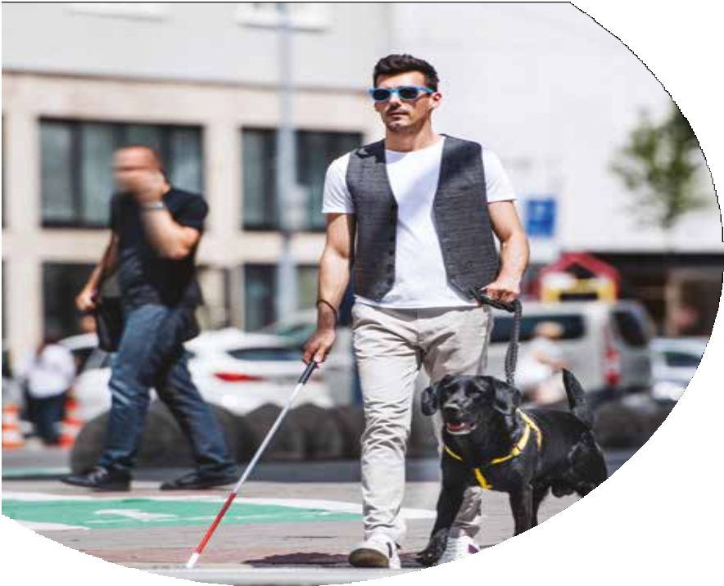
comms: 6758

Lancashire
Street Charter
-Preston City

Foreword
1
Disabled people face barriers getting around the towns and cities of Lancashire.
Even in familiar places, getting from one place to another can be a bit like navigating an obstacle course if you are a disabled person.

While some things can be difficult to change, other obstacles can be removed by all of us thinking about what we do, where we park our cars, how we ride our bicycles and if we really need to leave our bin in the street.

Lancashire County Council, working with our district council colleagues and our communities, wants to help create an inclusive environment where everyone feels
safe, secure and able to participate more fully in life.

The County Council is committed to working with disabled people and others to make our towns and cities more accessible to all.

I am delighted that together, working with disabled people, I can set out the aim to ensure the council works towards making our towns and cities accessible.

The first step is to deliver the Lancashire Street Charter and I hope that residents and visitors will feel they receive a warm and friendly welcome here in Lancashire.

County Councillor Keith Iddon Deputy Leader of
Lancashire County Council

Introduction
The Lancashire Street Charter was initiated and led by blind and partially sighted people through the Lancashire VI Forum, a group of blind, partially sighted and local sight loss organisations. It has been developed in consultation and with the support of disabled people and other groups and organisations in the city.
These include:
- RNIB
- Lancashire VI Forum
- Guide Dogs for the Blind

Our Street Charter is divided into sections that highlight the main issues disabled people face when negotiating the built environment. It aims to remove or reduce the barriers that disabled people and others with mobility issues face
in our city and sets out actions and commitments that everyone involved will abide by.

Engagement
The Public Sector Equality Duty places responsibilities on public sector organisations to involve disabled people and other groups when considering;
- New developments that need planning permission.
- Changes to the built environment such as town centre improvements and changes to highway layouts.
- The design and implementation of most street furniture.

We will:
- Make every effort to include groups that represent disabled people blind and partially sighted people in these consultations and on the city’s disability access forum, as people with sight loss face unique barriers in the built environment.
- Produce information in a format that is accessible to all.

Reporting Systems
The county council provides accessible reporting systems so that disabled people can report issues that affect them.
Issues such as temporary street obstructions, obstructive parking, overgrown vegetation and faulty crossings can be reported.

We acknowledge that online reporting systems cannot be accessed by everyone so we provide alternative methods to report issues including face to face and telephone.

Public Realm and Highway Developments
The county council wants to make the street safer for everyone
who uses them. It is recognised that areas where vehicles and pedestrians are in close proximity can be difficult to navigate
for some and the removal of controlled crossings can have a serious impact.

Lancashire County Council will work with disabled people when designing new public realm projects and major highway schemes to mitigate the impact on disabled people.

We will:
- Ensure blind, partially sighted and disabled groups are consulted on any significant schemes affecting the public realm in Preston City.
- Work with the City Council when we are consulted on development proposals to try to ensure that developments are more safe for disabled people.

Shared spaces can cause difficulties for disabled people and blind and visually impaired people find it difficult to navigate their way through such space.

We will not develop any new shared space schemes until such time as new Department for Transport guidance is issued when this positon will be reviewed.

Advertising Boards
Café
Advertising boards (‘A’ boards) and display stands outside premises can reduce the pavement width and can also present a trip hazard, particularly for those with mobility issues or impaired vision.
They may find it difficult to navigate the towns and cities of the county during the course of their daily lives and the presence of ‘A’ boards and display stands make it more difficult for them.

Street and Café Furniture
Street and café furniture such as tables and chairs, barriers, hanging baskets, bollards and lamp posts can be practical and
desirable but if they are overused or poorly managed or allowed to expand outside their agreed areas, they can make it difficult for disabled people moving around our towns and cities. The county council also has a responsibility to protect users of the public realm from terrorism and this will mean additional street furniture to protect those spaces.

We will:
- Raise awareness of the issues when considering our responses relating to ‘A’ boards, advertising structures, amenity planting and street furniture; and
- working with the City Council we will use the licensing process
to try to make sure all licensed café furniture, such as tables and chairs, is adequately guarded and less likely to cause a hazard.

Bins

Litterbins
The City Council will install, maintain and empty litterbins on the highway. The City Council will determine litterbin location, design, capacity and
emptying frequency based on site requirements.

Wheeled bins on the highway Wheeled bins can create an obstacle to all users and should be kept off the highway where practical and where relevant agreements are not in place. However, some businesses may not have the space to store wheeled bins off the highway and there may be requirements from Environmental Health to not store waste in the building. The city council will continue to work with businesses to ensure that the highway is
not obstructed and enforcement
action may be taken where appropriate.

Crossings
Lancashire County Council will look at how we can help improve pedestrian safety when crossing
our roads. We recognise that those who are blind or visually impaired may have particular issues and experience difficulties when using controlled, uncontrolled and courtesy crossings across carriageways.

Ensuring our crossings are well maintained fit for purpose helps all members of our communities maintain their independence.

We will:
- Ensure so far as practicable that crossings are correctly installed, monitored and maintained in line with national guidance regarding rotating cones, audible crossings and tactile paving; and
- consult with disabled groups before introducing these new crossings and when major upgrade works are planned.

Overhanging Vegetation
Overhanging trees, hedges and shrubs can cause problems for pedestrians, particularly for blind and visually impaired people as they cannot be detected by canes or guide dogs and can cause injury to people who may walk into them.

We will:
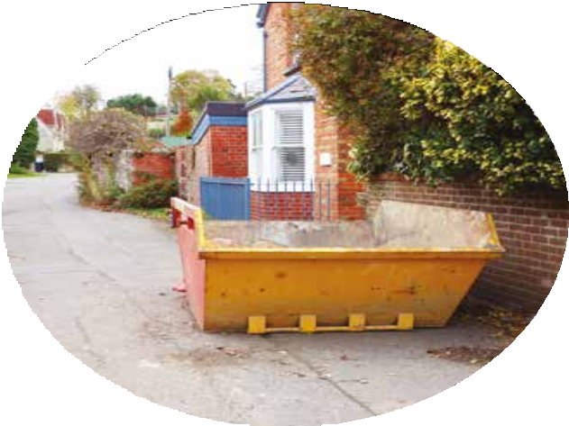
- Use powers under the Highways Act where appropriate to take required action by the owners of overhanging hedges or shrubs or occupiers of the land to try to ensure the passage of pedestrians is not endangered or obstructed.

Temporary Obstructions
Temporary items such as skips, scaffolding, construction materials, pedestrian barriers and road works are unavoidable but cause difficulties for road users.
The county council’s Highway Regulation team manage the permit process that allows such items to be placed in the highway.

We will:
- Ensure that the appropriate permits or licences are managed in accordance with legislation and that the applicants meet the requirements of their permit or licence.
- Ensure that contractors working on the highway are working in accordance with their permit and that the signing and guarding of their works is adequate; and
- where a footway cannot be kept clear then a clearly defined alternative route for pedestrians will be provided if possible.

Parking
Vehicles parking on the pavement, across dropped kerbs and at crossing points cause obstructions for pedestrians. This includes disabled, visually impaired
and blind people, those using wheelchairs and mobility scooters, and prams and pushchairs.

Parking in such a way can force pedestrians to walk in the carriageway and puts them at risk of colliding with a moving vehicle.

School parking presents a number of problems affecting the safety of pedestrians outside schools,
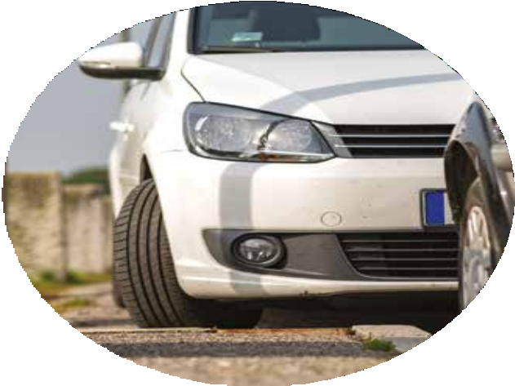
particularly for young children and the disabled.

We will:
- Use powers under highway legislation to act against obstructive parking where we can.
- Work with the Police, elected members and community groups to address issues where obstructive parking is an issue.
- Undertake random parking enforcement outside schools to encourage drivers to park appropriately and safely; and
- work with schools to raise awareness of inconsiderate parking and the problems it creates.

Taxis & Assistance Dogs
Some disabled people need the aid of an assistance dog to maintain
a level of independence and when they are out and about they may need to use a taxi or private hire vehicle.

The driver of a taxi or private hire vehicle cannot legally refuse to carry an assistance dog unless they have a medical exemption.
It is also illegal to charge a passenger more if they are travelling with an assistance dog.

We will:
- Take a zero tolerance approach on refusals to carry assistance dogs.
- Where a refusal is reported then it will be investigated and appropriate action taken.
- Carry out random checks with owners of assistance dogs.
- Only issue medical exemptions where it is supported by appropriate medical evidence; and
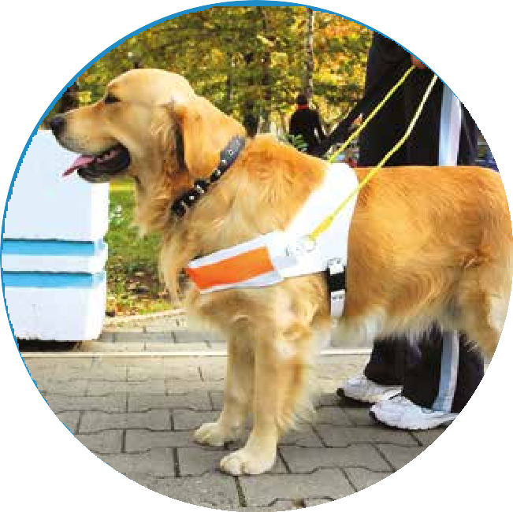
- exemption certificates will be provided in tactile and large print format.

